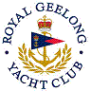 | Royal Geelong Yacht Club Inc.  Est 1859
Trophy Deed of Gift.

Trophy: | Pains Wessex Summer Series Club Member Award.
Presented by: | Pains Wessex
Date: | 2002
For: | Club Member Award
Remarks / Revisions | ‘Carved from the original teak of the Historical Barque “Polly Woodside”, launched in 1885
Click here for a List of Recipients

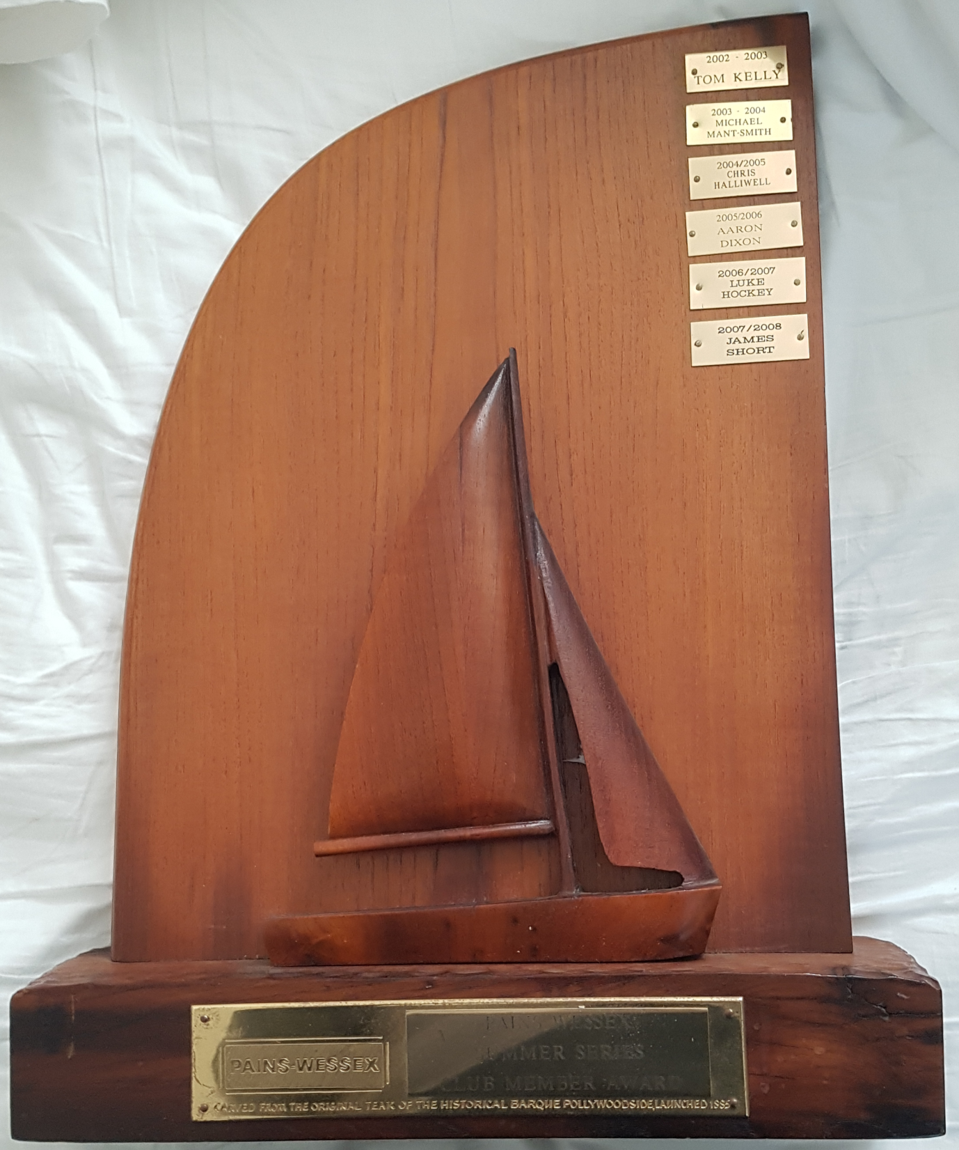

Further information Required. By the dates and names, it appears that the recipients; all being cadet members, could have fallen into the same classification as the Verforth trophy. It is likely that one of the Deakin University awards overshadowed this trophy, and is no longer awarded

